UI UX
DOMAIN : Jewellry websites
WEBSITES :
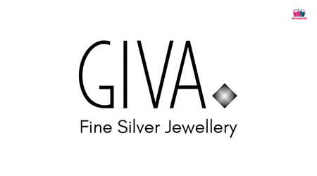
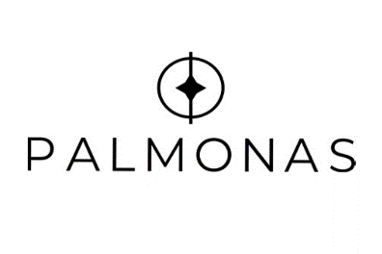



GIVA TANISHQ BLUESTONE PALMONAS

NAME: Mahek Katharotiya
PRN: 1262242460
ROLL NO: 12
PANEL: F
Giva: www.giva.co
Tanishq: www.tanishq.co.in
BlueStone: www.bluestone.com
Palmonas: www.palmonas.com

PROBLEM STATEMENT:
Critical analysis of interfaces: Analyse any one interference (website or mobile app) that you have interacted with that could be designed better. Focus on the interface design problems, rather than their engineering faults or business problems. Comment on its learnability, usability, consistency and metaphors.

Parameter | GIVA | BlueStone | PALMONAS | Tanishq
Learnability | Familiar e-commerce layout makes search, categories, wishlist and cart easy to understand. | Clear product-focused layout makes basic shopping tasks easy to learn. | Simple and modern layout is easy for first-time users to understand. | Familiar layout is easy to understand, though the large number of categories may require exploration.
Usability | Product browsing and purchasing are straightforward, but promotional sections can make the experience slightly busy. | Strong product discovery and shopping tools make browsing convenient, though the interface can feel information-heavy. | Simple product browsing and clear Add to Cart actions make shopping easy. | Strong shopping functionality, but the large product catalogue can make browsing more demanding.
Consistency | Consistent typography, product cards, buttons and jewellery-focused branding. | Consistent visual language and product presentation across shopping sections. | Strong minimalist branding and consistent product-card design. | Consistent premium branding, typography and product presentation across major sections.
Use of Metaphors | Search, heart/wishlist, account and shopping-bag icons use familiar e-commerce metaphors. | Familiar search, wishlist, account and cart symbols make functions recognizable. | Standard search, account, wishlist and cart metaphors are easy to understand. | Familiar shopping icons and category labels make most functions recognizable.
Navigation Structure | Many categories and subcategories provide choice but can make navigation lengthy. | Detailed categories and filters support exploration but can increase navigation complexity. | More focused categories create a relatively simple navigation structure. | Extensive category, occasion, gender and jewellery-type options provide powerful but complex navigation. (Tanishq)
Visual Hierarchy | Jewellery images attract attention, but promotional content can compete with product information. | Product imagery and pricing are prominent, supporting product comparison. | Product images and promotional offers dominate the interface, creating a strong shopping focus. | Large product imagery and curated sections create a premium hierarchy, although many sections compete for attention.
Accessibility | Basic text and icons are understandable, but stronger contrast and descriptive labels could improve accessibility. | Clear text and controls help usability, but accessibility could be strengthened through more explicit labels and contrast. | Clean layouts and straightforward text support readability, though accessibility can still be improved. | Clear typography and structured content help, but the large amount of content may increase cognitive load.
Responsiveness | Layout adapts to smaller screens, although navigation and product grids can become crowded. | Responsive shopping experience supports browsing across devices. | Minimal layout translates well to smaller screens, with fewer competing elements. | Responsive interface supports mobile browsing, although the extensive content can feel dense on smaller screens.
Efficiency of Interaction | Search, filters, wishlist and cart make product selection efficient, but multiple categories can require extra clicks. | Strong filtering and sorting can speed up product discovery. | Simple category browsing and direct cart actions make interaction relatively efficient. | Extensive filters and sorting provide control but can require more interaction to narrow choices.
Feedback & System Status | Cart and wishlist actions provide feedback, but some feedback could be more prominent. | Shopping actions generally provide confirmation, although clearer status indicators could improve confidence. | Cart and product-selection feedback is straightforward and easy to understand. | Add-to-cart and product-selection interactions provide feedback, while additional status cues could make complex actions clearer.
Error Prevention & Recovery | Forms guide users, but clearer error messages and recovery instructions could improve correction. | Product and checkout flows provide useful controls, but more explicit recovery guidance could help users. | Simple shopping flow reduces mistakes, although clearer form-error guidance would improve recovery. | Multiple product and checkout options provide control, but error recovery could be made more explicit for complex transactions.
Aesthetic & Minimalist Design | Attractive jewellery photography creates a premium look, but promotional content can sometimes feel cluttered. | Premium imagery and structured layouts create a polished jewellery-shopping experience. | Strong minimalist and modern aesthetic with relatively little visual clutter. | Elegant and premium visual design, although the amount of content can reduce the minimalist feel.
Content Readability | Product names, prices and basic information are clear, but secondary information could use stronger hierarchy. | Product details are informative, though the amount of information can feel dense. | Shorter product presentation makes key information easy to scan. | Product information is detailed and organized, but the extensive catalogue creates more reading load.
Search & Discoverability | Search, categories and extensive filters make products discoverable, although too many options can increase decision load. (GIVA Jewellery) | Strong search, category and filtering options support detailed product discovery. | Focused collections and category browsing make discovery simple, though fewer options may limit filtering depth. (PALMONAS) | Excellent discoverability through jewellery type, price, occasion, gender and other categories, but the number of choices can be overwhelming. (Tanishq)
Performance Perception | Immediate visual responses and shopping feedback generally make the interface feel responsive. | Smooth product browsing creates a generally responsive perception. | Simple pages and focused layouts create a quick and lightweight feel. | Rich imagery and extensive product content can make some pages feel heavier, even when interactions remain clear.
Trust & Credibility | Strong branding, product information, reviews and shopping policies support user confidence. | Established jewellery brand presence, product information and shopping guidance strengthen credibility. | Warranty, return information, product specifications and store presence support trust. (PALMONAS) | Strong brand recognition, quality information, transparency and assurance features create high perceived credibility. (Tanishq)
Personalization | Wishlist, personalized jewellery and product recommendations provide some personalization. (GIVA Jewellery) | Recommendations and product browsing features provide some personalization, though deeper customization could improve the experience. | Collections and style-oriented categories help users find products suited to their preferences. | “Curated For You,” recommendations and gender/occasion-based shopping provide stronger personalization. (Tanishq)
User Satisfaction | Attractive design and familiar shopping features create a good experience, but simpler navigation could improve satisfaction. | Detailed shopping tools and product variety support satisfaction, though the information density can feel overwhelming. | Clean design and simple shopping flow create a pleasant, modern experience. | Premium design, extensive selection and strong trust cues create high satisfaction, although the interface can feel content-heavy.

Learnability:
Website | Rating | Points
GIVA | 9/10 | • Familiar e-commerce layout makes it easy for first-time users to understand the website.  • Search, categories, wishlist and shopping bag are clearly recognizable.  • Product categories are easy to understand and help users start browsing quickly.  • Promotional sections are simple to understand, makes the homepage seem crowded
BlueStone | 8.5/10 | • Clear jewellery categories and product-focused layout make the basic functions easy.  • Search, filters, wishlist and cart use familiar e-commerce conventions.  • Detailed categories give users good guidance when browsing.  • The number of categories and options can be overwhelming for a first-time user to explore.
PALMONAS | 9/10 | • Clean and modern interface makes the website easy to understand at first glance.  • Simple navigation and clear product categories reduce the learning effort.  • Product cards provide familiar information such as image, name and price.  • Fewer complex options make it relatively easy for new users to start shopping.
Tanishq | 8/10 | • Familiar e-commerce structure makes basic actions such as search, browsing and adding products easy to learn.  • Clear jewellery categories help users understand the main shopping options.  • Strong branding and visual cues make important sections recognizable.  • The large number of categories, collections and shopping options can require more exploration for a first-time user.
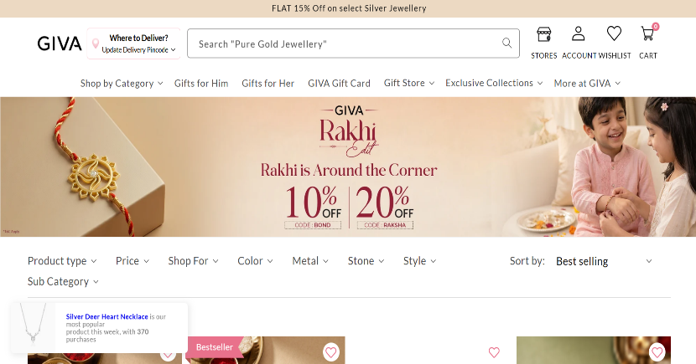

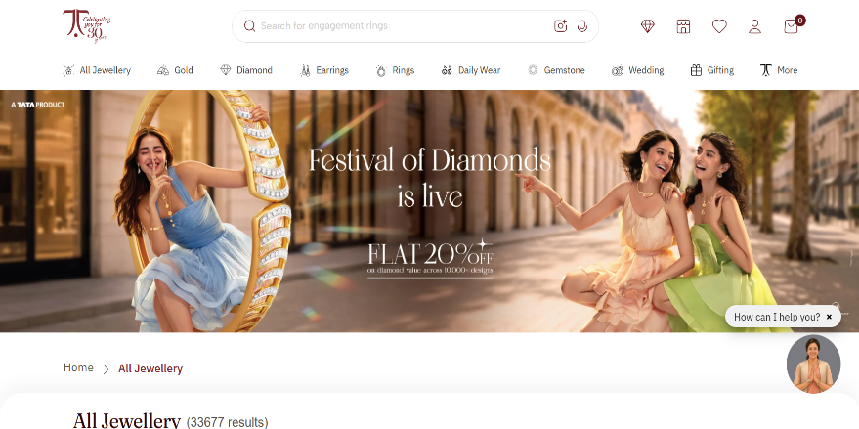
GIVA

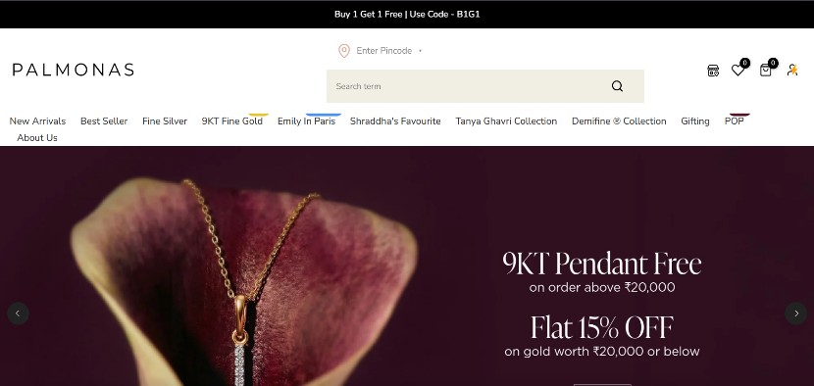

PALMONAS
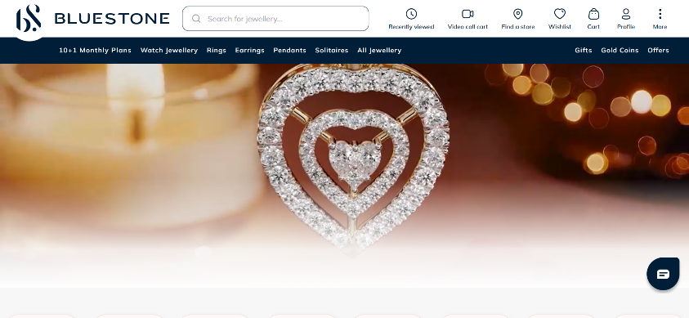

BLUESTONE
Usability:
Website | Rating | Justification
GIVA | 9/10 | • Product images, names and prices are clearly presented.  • Search, filters, wishlist and cart make product browsing convenient.  • Promotional sections can sometimes make the shopping experience slightly busy.
BlueStone | 9/10 | • Detailed categories and filters make it easy to find specific jewellery.  • Product information is presented clearly for comparison.  • The large number of options can make the interface feel information-heavy.
PALMONAS | 9/10 | • Clean and simple layout makes browsing products straightforward.  • Product cards clearly display important information such as images and prices.  • Simple navigation reduces the number of steps needed to explore products.  • The relatively focused catalogue makes shopping less overwhelming.
Tanishq | 8/10 | • Clear product categories, search and filtering support product browsing.  • Product information and shopping actions are easy to understand.  • Strong organization helps users explore different jewellery collections.  • The large catalogue and numerous categories can require more effort to find a specific product.
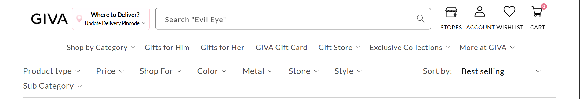

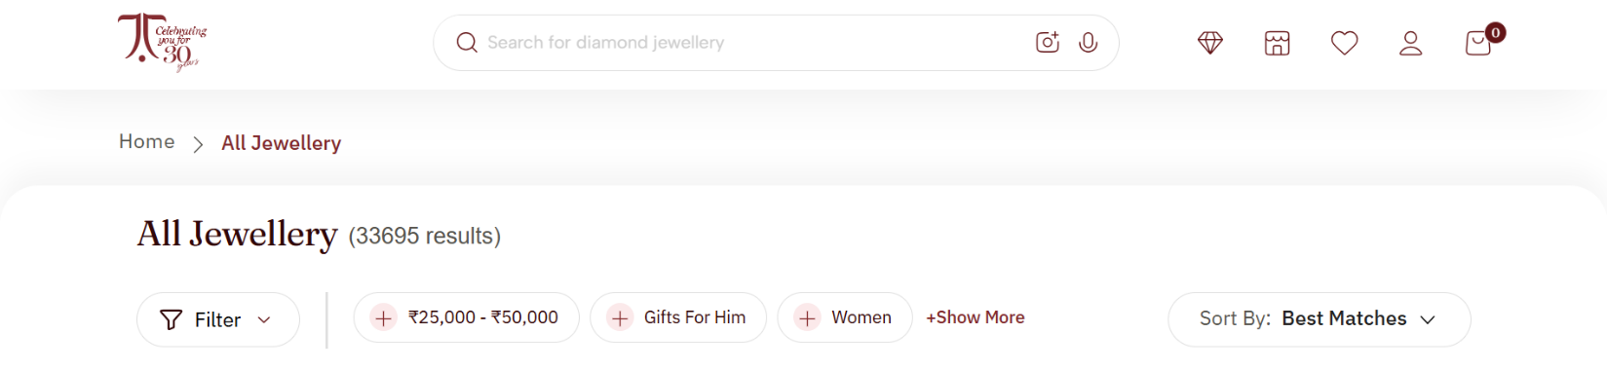
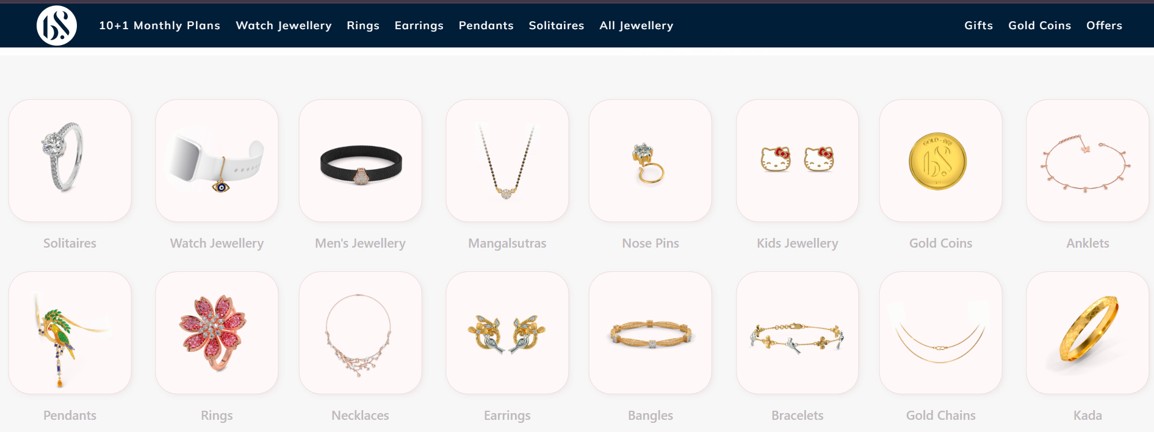
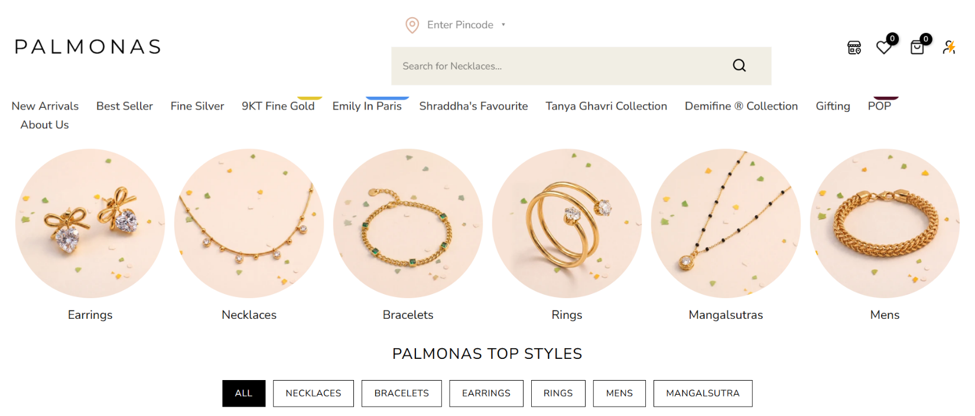

Error prevention and recovery:
Website | Rating | Justification
GIVA | 8/10 | • Clear product selection and quantity controls help prevent accidental actions.  • Cart allows users to review products before proceeding.  • More specific error messages and recovery guidance could make mistakes easier to correct.
Tanishq | 8/10 | • Form validation helps prevent incomplete information during checkout.  • More prominent recovery instructions could help users correct errors faster.
BlueStone | 8/10 | • Detailed product information helps users make informed choices before adding items.  • Checkout forms help prevent missing information.  • Clearer error messages and recovery options could improve the experience further.
PALMONAS | 9/10 | • Simple navigation and focused shopping flow reduce the chances of user mistakes.  • The simpler interface allows users to recover from mistakes with relatively little effort.

Use of metaphors:
Website | Rating | Justification
GIVA | 9/10 | • Uses familiar heart icon for wishlist/favourites.  • Shopping bag/cart icon clearly represents items selected for purchase.  • Magnifying glass represents search and is immediately recognizable.  • User/account icon represents the customer's profile.  • Familiar metaphors make the interface easy for first-time users to understand.
BlueStone | 9/10 | • Uses familiar search, wishlist, account and cart icons.  • Jewellery categories use recognizable labels and visual representations.  • Standard e-commerce symbols make important actions easy to identify.  • Consistent use of familiar icons reduces the learning effort for users.
PALMONAS | 9/10 | • Uses familiar search, wishlist, account and shopping bag icons.  • Product categories and collection names clearly represent their functions.  • Familiar symbols allow users to understand actions without additional instructions.  • The simple interface makes the metaphors easy to recognize and remember.
Tanishq | 9/10 | • Uses familiar search, wishlist, account and shopping bag icons.  • Visual product categories help users understand different jewellery sections.  • Common e-commerce metaphors make navigation intuitive for new users.  • Consistent icons and labels help users predict what will happen when they interact with an element.

,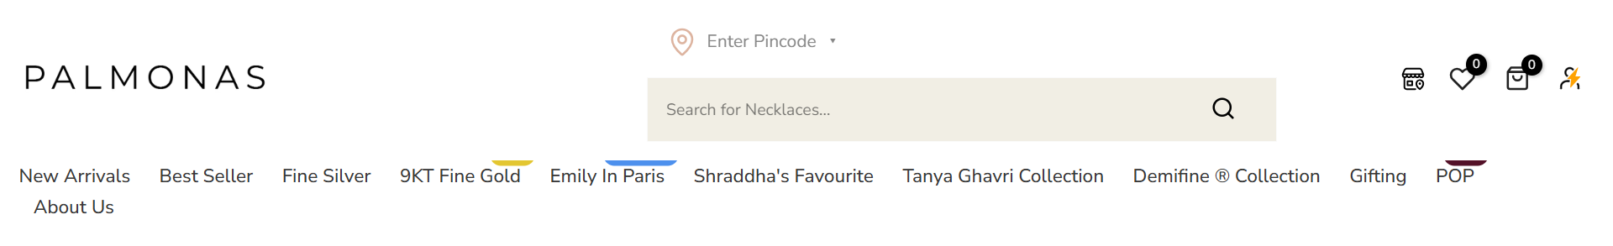



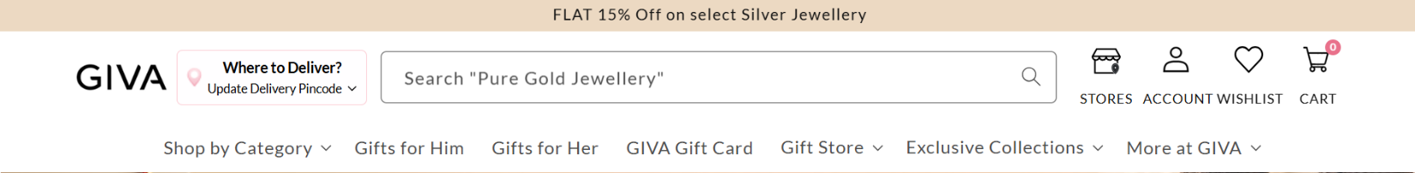

8 golden rules of interface design:
Golden Rule | GIVA | BlueStone | PALMONAS | Tanishq
1. Strive for Consistency | Consistent typography, colours, icons, buttons and product cards. | Consistent layouts, product presentation and navigation elements. | Strongly consistent minimalist design and visual branding. | Consistent premium branding, typography and product presentation.
2. Seek Universal Usability | Familiar shopping controls make it easy for most users, but accessibility improvements could help. | Clear shopping functions support different users, although the information-rich interface can be demanding. | Simple interface and straightforward navigation make it accessible to a broad range of users. | Familiar e-commerce structure is easy to use, but the extensive catalogue may increase cognitive load.
3. Offer Informative Feedback | Cart and wishlist actions provide feedback, but some feedback could be more prominent. | Product and cart interactions generally provide clear confirmation. | Simple interactions provide clear and understandable feedback. | Important actions provide feedback, though some system-status information could be clearer.
4. Design Dialogs to Yield Closure | Cart additions and shopping steps generally provide a sense of completion. | Shopping actions and product selection provide clear progression toward completion. | Simple shopping flow makes task completion easy to understand. | Major shopping steps are clear, but the larger number of options can make task completion feel less direct.
5. Prevent Errors | Cart review and required information help prevent mistakes, but error guidance could be improved. | Product details and selection controls help reduce errors. | Simple interface reduces opportunities for mistakes. | Product and checkout controls help prevent mistakes, but clearer recovery guidance would help.
6. Permit Easy Reversal of Actions | Wishlist, cart editing and product removal allow users to change decisions easily. | Users can modify or remove products before completing the purchase. | Simple cart and product controls make reversing actions straightforward. | Cart and selection controls allow users to review and change choices before purchase.
7. Keep Users in Control | Users can search, filter, compare, wishlist and modify cart selections. | Extensive filtering and product options give users strong control over browsing. | Simple categories and shopping controls provide clear user control. | Extensive categories, filters and shopping options provide users with considerable control.
8. Reduce Short-Term Memory Load | Familiar icons help, but numerous categories and promotional elements can increase cognitive load. | Detailed product information is useful but can require users to remember more choices. | Minimal layout and focused categories reduce the amount users need to remember. | Large catalogue, multiple categories and extensive information can create higher cognitive load.

